|  |  |  |
| --- | --- | --- |
| |  |  | | --- | --- | | Ex.No: 1 Date : | **Develop an application that uses GUI Components, Fonts and**  **Colors** |     **AIM:**  To develop an application that uses GUI Components, Fonts and Colors.  **PROCEDURE:**   1. Open Eclipse IDE. 2. Create the project Ex_No_1. 3. Go to package explorer in the left-hand side. Select the project Ex_No_1. 4. Go to res folder and select layout. Double click the activity_main.xml file. 5. Now you can see the Graphical layout window. 6. Drag and drop the following components:    1. One Text View with text MAD Lab    2. Three Buttons with labeled as Change Font Size, Change Font Color and Change Font Style 7. Again, go to package explorer in the left-hand side. Select the project Ex_No_1. 8. Go to src folder. Double click the MainActivity.java file. 9. In java file write the activities done by the application such as, actions of buttons. 10. Finally run the android application.   **PROGRAMS: *activity_main.xml:***  <RelativeLayout xmlns:android=[*"http://schemas.android.com/apk/res/android"*](http://schemas.android.com/apk/res/android)xmlns:tools=[*"http://schemas.android.com/tools"*](http://schemas.android.com/tools)an-  droid:layout_width=*"match_parent"* android:layout_height=*"match_parent"* android:paddingBottom=*"@dimen/activity_vertical_margin"* android:paddingLeft=*"@dimen/activity_horizontal_margin"* android:paddingRight=*"@dimen/activity_horizontal_margin"* android:paddingTop=*"@dimen/activity_vertical_margin"* tools:context=*"com.example.ex_no_1.MainActivity"* >    <TextView android:id=*"@+id/textView1"* android:layout_width=*"wrap_content"* android:layout_height=*"wrap_content"* android:layout_alignParentTop=*"true"* android:layout_centerHorizontal=*"true"* android:layout_marginTop=*"53dp"* android:text=*"MAD Lab"*  android:textAppearance=*"?android:attr/textAppearanceLarge"* tools:ignore=*"HardcodedText"* />    <Button android:id=*"@+id/button1"* android:layout_width=*"wrap_content"* android:layout_height=*"wrap_content"* android:layout_alignParentLeft=*"true"*  2 |

android:layout_alignParentRight=*"true"* android:layout_below=*"@+id/textView1"* android:layout_marginTop=*"64dp"* android:text=*"Change Font Size"* tools:ignore=*"HardcodedText"* />

<Button android:id=*"@+id/button2"* android:layout_width=*"wrap_content"* android:layout_height=*"wrap_content"* android:layout_alignParentLeft=*"true"* android:layout_alignParentRight=*"true"* android:layout_below=*"@+id/button1"* android:text=*"Change Font Color"* tools:ignore=*"HardcodedText"* />

<Button android:id=*"@+id/button3"* android:layout_width=*"wrap_content"* android:layout_height=*"wrap_content"* android:layout_alignParentLeft=*"true"* android:layout_alignParentRight=*"true"* android:layout_below=*"@+id/button2"* android:text=*"Change Font Style"* tools:ignore=*"HardcodedText"* />

</RelativeLayout>

***MainActivity.java:***

**package** com.example.ex_no_1;

**import** android.support.v7.app.ActionBarActivity; **import** android.graphics.Color; **import** android.graphics.Typeface; **import** android.os.Bundle; **import** android.view.View;

**import** android.view.View.OnClickListener; **import** android.widget.Button; **import** android.widget.TextView;

**public class** MainActivity **extends** ActionBarActivity { **float** font = 20; **int** count = 1; Button b1,b2,b3; @Override

**protected void** onCreate(Bundle savedInstanceState) { **super**.onCreate(savedInstanceState); setContentView(R.layout.*activity_main*); **final** TextView t1 = (TextView) findViewById(R.id.*textView1*); t1.setTextSize(15);

b1 = (Button) findViewById(R.id.*button1*); b1.setOnClickListener(**new** OnClickListener() { **public void** onClick(View view) { t1.setTextSize(font); font = font + 5; **if** (font == 50)

|  |  |  |
| --- | --- | --- |
| } | } | font = 20;  } });  b2 = (Button) findViewById(R.id.*button2*); b2.setOnClickListener(**new** View.OnClickListener() { **public void** onClick(View view) { **switch** (count) { **case** 1: t1.setTextColor(Color.*parseColor*("#7f00ff")); **break**; **case** 2: t1.setTextColor(Color.*parseColor*("#00FF00")); **break**; **case** 3: t1.setTextColor(Color.*parseColor*("#FF0000")); **break**; **case** 4: t1.setTextColor(Color.*parseColor*("#0000FF")); **break**;  } count++; **if** (count == 5) count = 1;  } }); b3 = (Button) findViewById(R.id.*button3*); b3.setOnClickListener(**new** OnClickListener() {  @Override  **public void** onClick(View view) { **switch** (count) { **case** 1: t1.setTypeface(Typeface.*DEFAULT*, Typeface.*ITALIC*); **break**; **case** 2: t1.setTypeface(Typeface.*MONOSPACE*, Typeface.*NORMAL*); **break**; **case** 3: t1.setTypeface(Typeface.*SANS_SERIF*, Typeface.*BOLD*); **break**; **case** 4: t1.setTypeface(Typeface.*SERIF*, Typeface.*BOLD_ITALIC*); **break**;  } count++; **if** (count == 5) count = 1;  }  });  4 |

**OUTPUT:**

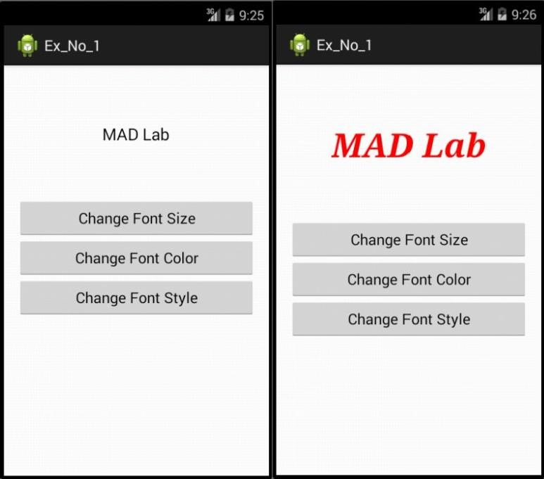

**RESULT:**

Thus the application that uses GUI Components, Fonts and Colors has been developed and the output was verified.